Git Hub Task Step by Step’s
Creating new Directory: -
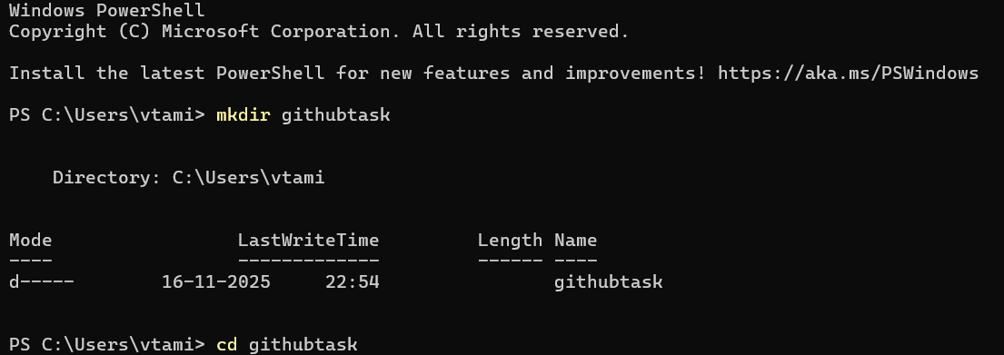
Creating Script File: -
Initiate an empty repository on GitHub: -
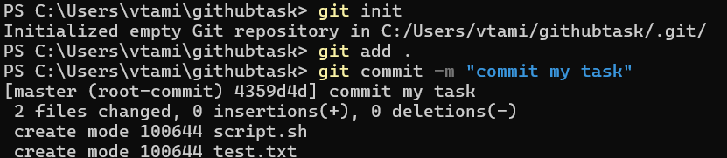
Convert the local directory into a Git repository, and link it to GitHub for pushing the code into the repository: -
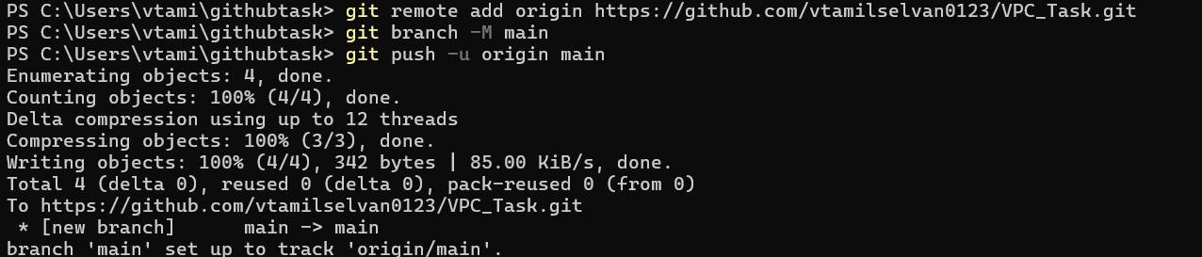
Merge: -
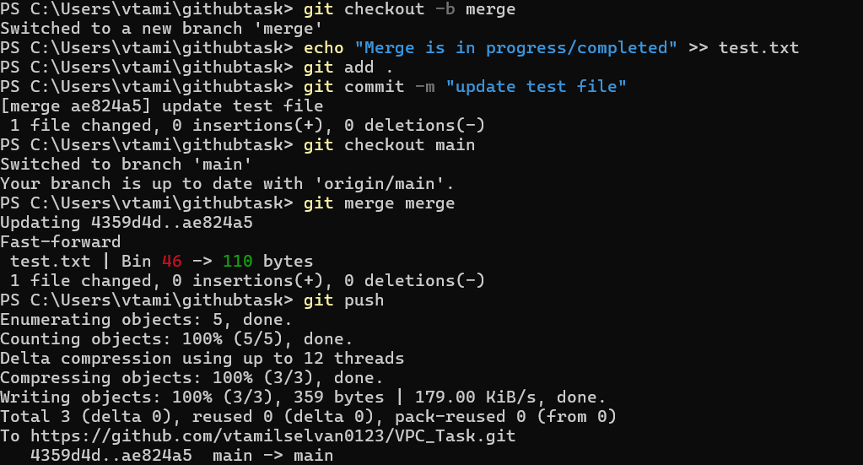
Rebase: -
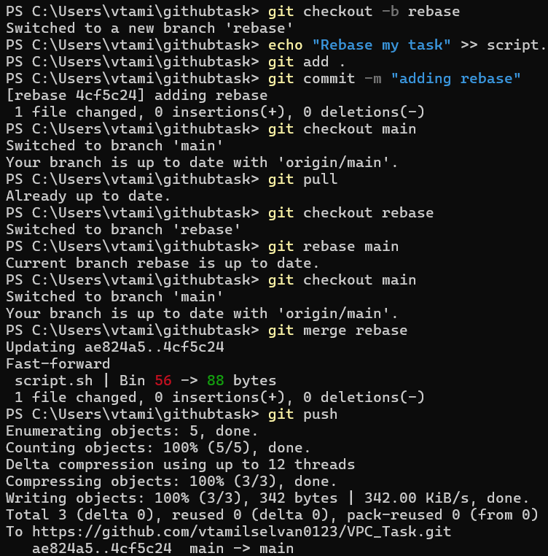
Stash: -
